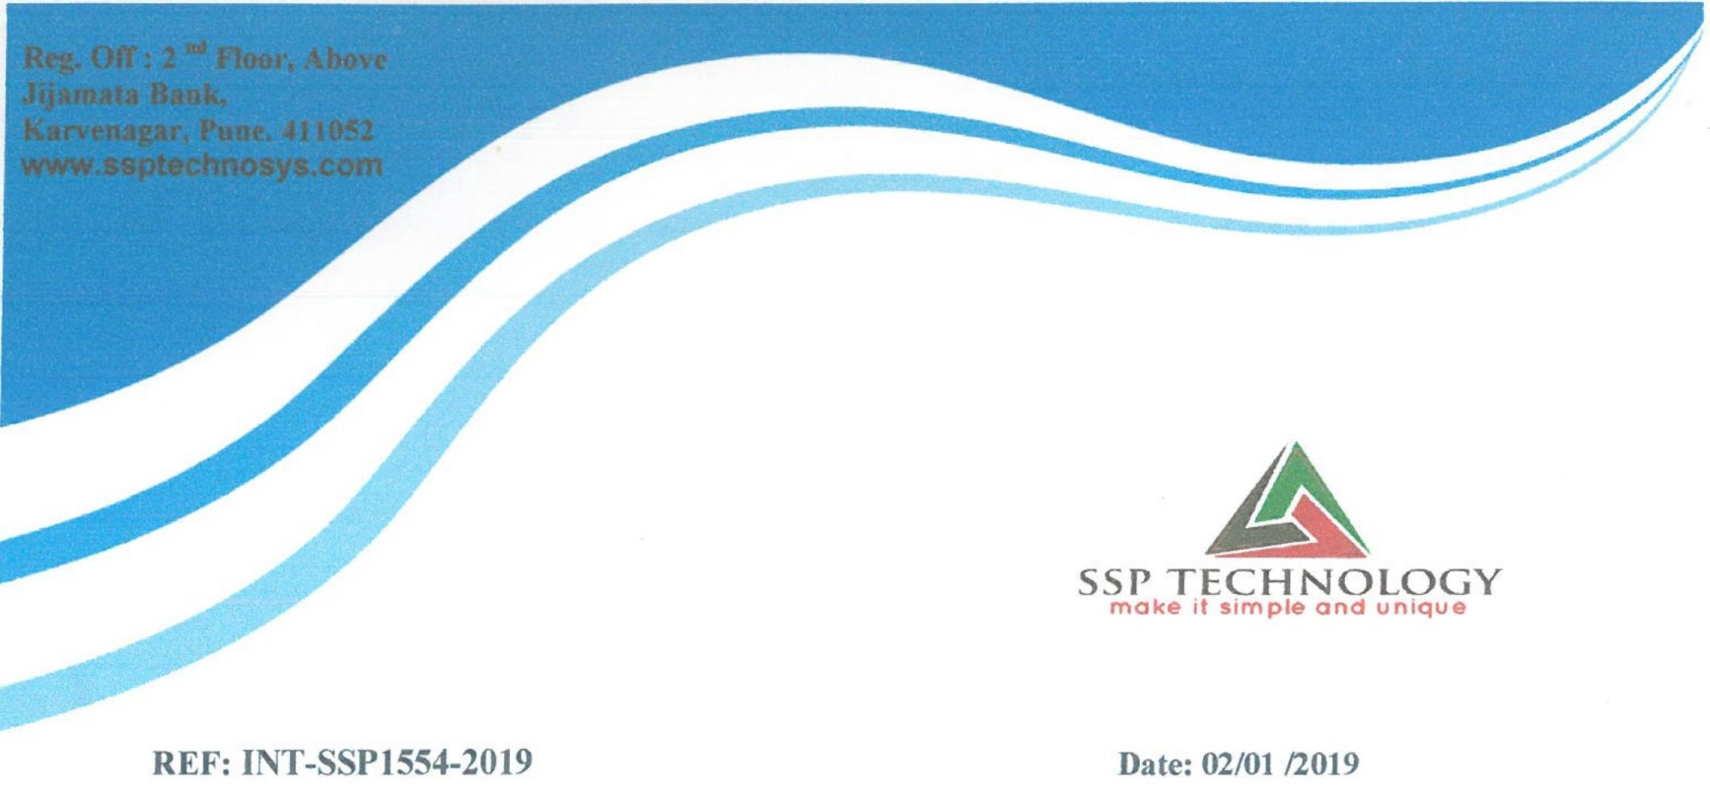

Dear **Mr. Omkar Arun Surve**,

This letter is with references to your internship application for the post of

“**Java Developer Intern**” We are happy to inform you that you have been

selected for the applied post and are offering internship position which will

be for a minimum period of **Six Month**. After further review of your

performance, you will be given a probation period

